Module 10 Discussion

Using the 100 Things Every Designer Should Know About People reading assignment, select two (2) of the "things" you read about, include the number and title of the "thing" (i.e., #36 Time is Relative) , and then do two embellishments, one embellishment and one visual example, or two visual examples.
- Embellish: Tell us something that the reading did not tell us on that specific "thing" or embellish on what was presented. Be sure you are adding meaningful content to the conversation and not just making noise. Your addition can be a link to an article, or you can write out your embellishment.
- Visual Example: Provide us with a graphic example that is relevant to web design. This can be something you create or something you find. Again, be sure to add meaningful content to the conversation.

Topic # 81: The More Difficult Something is to Achieve, the more People Like it.
Embellishment:
For the embellishment on this one, I’m going to talk about video games. Trophies and Achievements are a thing that consoles added a long time ago to add another layer to video games. Beyond the main story and side quests, you can get trophies for completing certain things in specific ways. For example, in Fallout 3, you get an achievement for maxing out your Karma Meter to the positive end, and another one for maxing it out to the negative end. Bronze, Silver, and Gold organize these trophies (for PlayStation anyway) to indicate how difficult they are to achieve. They also added a “this percent of players who played this game have this trophy) as an added way to compare yourself to fellow gamers.
If you get every trophy for a game, you get a special trophy for that game called a Platinum Trophy. Achieving this trophy gets you literally nothing, except the feeling of pride that you accomplished something that not many people do (in most games, it’s less than 0.1% of players who get it). Before I had a family, I made it my mission to earn the platinum trophy for all my favorite games (now I don’t have that kind of time, since they typically involve multiple playthroughs and winning on the most challenging difficulty levels). On your profile, your trophies are prominently displayed so other users can compare them.
In web design, many places leverage this type of perceived prestige. Social Media sites have badges you can earn, like “verified user” (though this one is diluting what it means since many places you pay a monthly fee for it rather than gain it through actual verification and community engagement), or “top contributor,” where if you post more than a certain percentage of the community. Other examples might include “100-day streak” or “Elite member,” which puts you above other members of the community. These things make people want to engage more. But it needs to be fair (if the difficulty is just an arbitrary barrier, like an admin says yes or no with no guidelines, many will disengage), possible (IQ 180 or higher required), and feel earned (no paying $8 a month for a verified badge)
Visual Example:
Here is my PSN profile, showing the trophies (Yes, I have only 8 Platinum…)
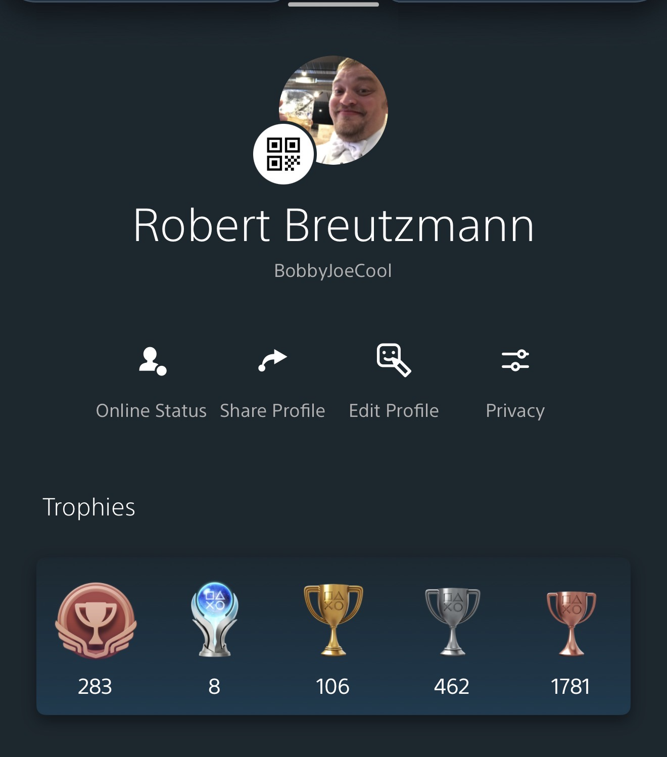

Topic # 80: Listening to Music Releases Dopamine in the Brain
Embellishment:
My embellishment here is quite simple. I listen to music while I work on homework. My playlist consists of music intended for background during D&D sessions (no lyrics, just acoustic). Some of it is video game music, and some is original compositions I got from a composer who shares his work on YouTube, Michael Ghelfi. The reason I do this is that the music creates a white noise that drowns out the background noise around me, preventing distractions (my dog settling in his bed, the trucks driving by on the road in front of my house, which is a major highway, etc.). Now, the reason I’m so easily distracted is that I have ADHD. If I start getting distracted, sometimes that means I get WAY off where I’m supposed to be and end up doing something completely irrelevant to what is essential at this time, and then deadlines come too close or even pass.
Now, this topic is about the dopamine released, and while the music I listen to while working/studying is not overtly pleasurable or euphoric, it is relaxing and comforting. A moderate and steady amount of dopamine is released, which calms stress and anxiety. Dopamine is often referred to as a “pleasure chemical.” Dopamine plays a significant role in motivation, attention, stress, and anxiety as well. In my example, the background music is providing just enough input to prevent my ADHD brain from “over seeking” the dopamine from other places.
Now, apply this idea to web design. Websites are just like the environment I described in my home, but in different ways. Instead of my dog settling in his bed, there’s an ad playing from somewhere on the page. Instead of a truck driving by, there’s a pop-up ad. Instead of lyrical music, there are loud colors that draw our attention to places where they shouldn’t be. Websites can simulate the feeling that the music creates by filtering out “background noise.” If you think about websites that you like going to, I’d be willing to bet that most of them don’t have popups (or very few), ads are constrained to the margins if they exist at all, they don’t auto-play music, and they are designed in a way not to blast your senses with loud colors. And the websites you really don’t like have one or many of those things.
So, the point is, when designing a website, keep the “background” noise down to avoid overwhelming the user with distractions.

